Kenny Nguyen
DATA 205
Professor Perine

Maryland Appeals and Grievances Ingestion/ Cleaning
- I downloaded the Reports on the Health Care Appeals and Grievance Law from Maryland.gov for the years 2021-2024.
2021: https://insurance.maryland.gov/Consumer/Appeals and Grievances Reports/2021-Report-on-the-Health-Care-Appeals-and-Grievance-Law.pdf
2022: https://insurance.maryland.gov/Consumer/Appeals and Grievances Reports/2022-Report-on-the-Health-Care-Appeals-and-Grievance-Law.pdf
2023: https://insurance.maryland.gov/Consumer/Appeals and Grievances Reports/2023-Report-on-the-Health-Care-Appeals-and-Grievance-Law.pdf
2024: https://insurance.maryland.gov/Consumer/Appeals and Grievances Reports/Health-Care-Appeals-and-Grievance-Law-2024-Report-Insurance-Article-15-10A-06-b-3.pdf
- I opened each PDF in Adobe Acrobat and deleted all pages that did not include the appendices.
- I used Adobe Acrobat's built-in feature to convert each year's PDF into Excel format.
- After conversion, the Excel files were not properly formatted. The columns were disorganized, and data spilled across multiple columns, which would make EDA messy and unstructured.

Excel File After Conversion:
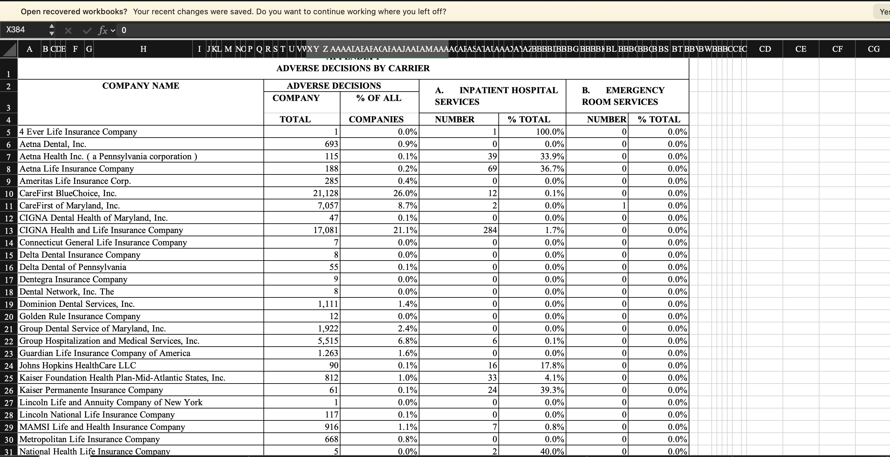
- In each Excel workbook, I renamed the file to "MIA (Year)" and created eight new sheets-one for each appendix. I renamed each sheet according to the appendix title, for example:
Adverse Decisions by Carrier
Grievance Decisions by Carrier
Disposition of Carrier Grievance Decisions
Grievance Decisions by Carrier for Hospital Length of Stay (LOS)
Time Frame for Rendering a Grievance Decision by Carrier - Emergency Cases
Time Frame for Rendering a Grievance Decision by Carrier - Non-Emergency Cases
Internal Grievances Filed Considered Emergency Cases as Reported by Carrier
Administration Complaints
- I opened a second window of the same Excel workbook. One window displayed the original report, and the other displayed the appendix sheet I was working on.
- I manually added column headers based on what was shown in the appendix.
- I highlighted as many values as possible from the appendix (excluding column names) and pasted only the values into the corresponding sheet. I repeated this process until reaching the “Total” row, which indicates the end of the appendix.
- I wrapped the company name’s column so they would remain within a single cell and clearly indicate where each column ends.
Worksheet looked like this
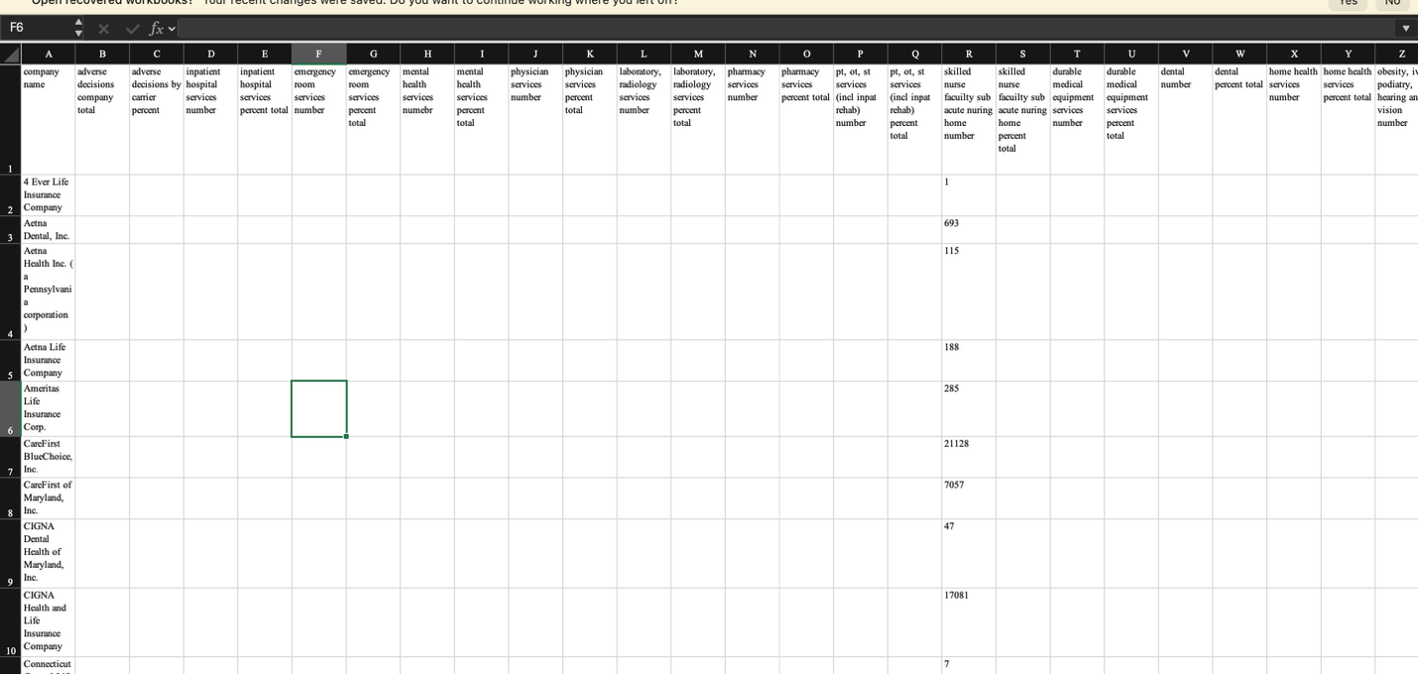

- I selected all empty columns (from the first company name through the “Total” row), deleted them, and chose the “Shift cells left” option. I repeated this process until all columns were properly aligned.
One completed appendix looked like this:
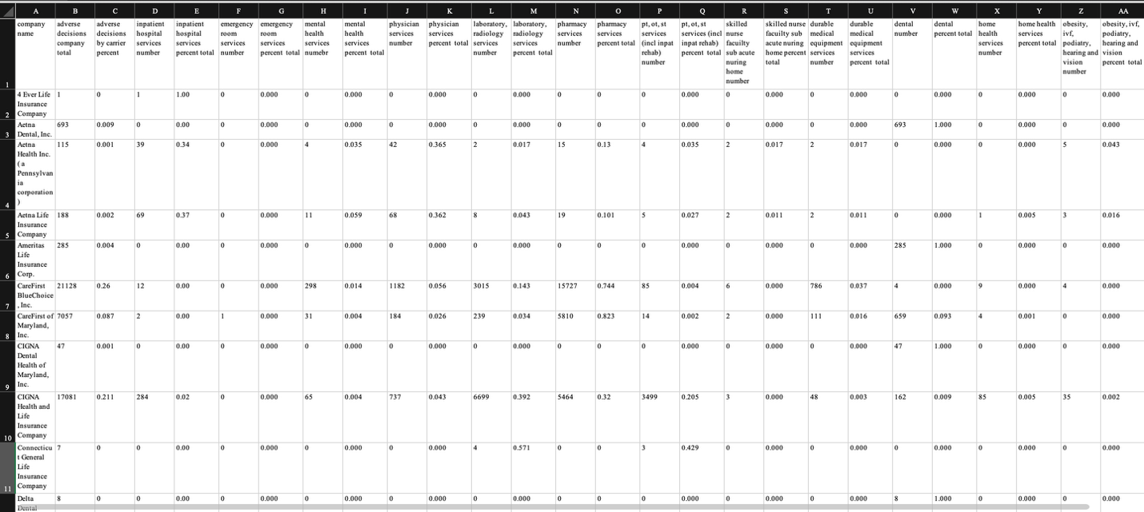
- I repeated this entire process for all years and appendices.
Merging All Datasets into One
To perform effective and efficient EDA, I consolidated all datasets into one complete, organized, and easy to understand dataset.
- I created a new blank Excel workbook named “MIA Appeals and Grievances.”
- I opened all yearly datasets.
- I copied and pasted all values from the first appendix (2021) into the new workbook.
- I repeated this process for all the years, pasting each year’s data below the previous one.
- I added a Year column and filled in the appropriate year for each row.
- I then copied the column headers from other appendices and pasted them into the main sheet. For service-related columns, I distinguished whether they represented adverse decisions or grievances.
- I used Excel’s built-in XLOOKUP function to populate the dataset:
“=XLOOKUP(B2, '[MIA (YEAR).xlsx](Appendix Name)'!$A:$A'[MIA (YEAR).xlsx](Appendix Name)'!$(Column):$(Column), "N/A", 0)”
This formula searches the original appendix sheets by company name and fills in the corresponding data within the specified columns. If a company does not have data for a specific appendix, the value is represented with “N/A”.
- I cross-checked the MIA Appeals and Grievances dataset with the original reports to ensure all values aligned correctly and that no companies were missing. This step was critical to ensure data accuracy.
- I adjusted the formula for each year and appendix and repeated the process until all companies and years were fully populated

Completed MIA Appeals and Grievances:
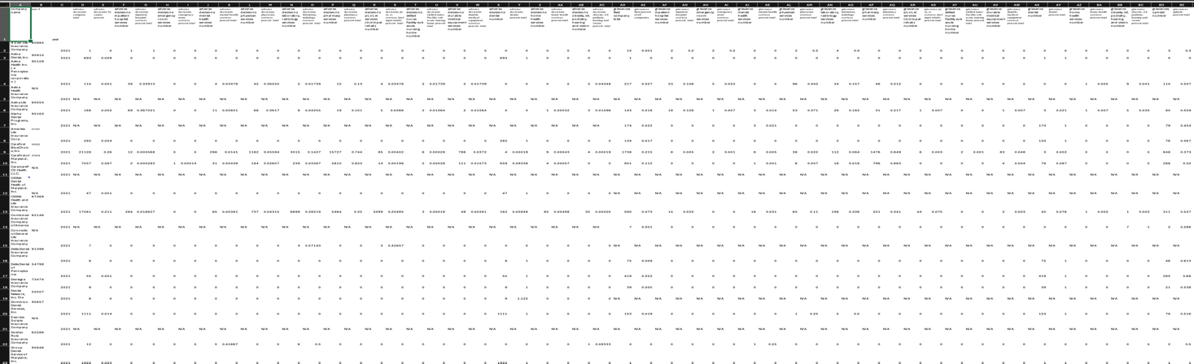
Since one appendix breaks data down by procedure type, merging it into the main dataset was difficult due to the lack of a common key.
- I created a separate Excel workbook called “Admin Complaints”
- I copied and paste the appendix data by year into it
- I added a Year column and filled in the appropriate year for each row.
Completed Admin Complaints:
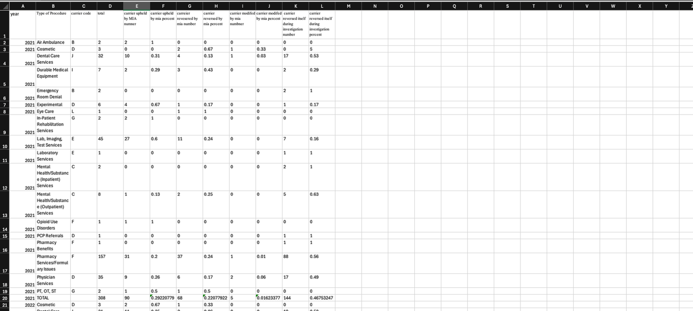

Final Data Preparation for R
- I converted both the MIA Appeals and Grievances and Admin Complaints datasets into CSV format for use in RStudio.
- I replaced all “N/A” values with blank cells so that RStudio would interpret them as null values rather than character strings.
- After importing the data into RStudio, I reviewed the column names and noticed that they contained periods (adverse.decisions.company.total), which I did not prefer.
- I used the following code to clean the column names:
“names(mia) <- tolower(names(mia))
names(mia) <- gsub(' ',"_",names(mia))
names(mia) <- gsub("\\.", "_",names(mia))”

This code converts all column names to lowercase and replaces spaces and periods with underscores for consistency and readability.

